WB Payment Environmental Services for SFM

About the project

CNVP in a consortium with NRS Kosovo, REGEA Croatia, Diava Consulting, Albania, Faculty Forestry, Macedonia and Wageningen University, The Netherlands is implementing the WB-PROFOR project on ‘Study and Analysis of Innovative Financing for Sustainable Forest Management in the Southwest Balkans. This is a two year project, started November 2011, focused on reviewing and studying the role and contribution of Sustainable Forest Management to securing environmental services. The project is implemented through two cases; in Albania on SFM and watershed management in the Ulza watershed, and in Kosovo on SFM and wood biomass production and use.

The project using the two cases will define scientifically sound methodologies, establish key baseline data for these cases and provide quantitative estimates of the value of some specific targeted environmental services. The project will based on the learning and results propose mechanisms to start or increase payment for environmental services in the two cases.

An important aspect of the project is dissemination of the results and experiences. The outcomes of the study and analysis will be shared and provided at a regional and more international level. A deliberate participation and consultation process is used throughout the project.

Refer also to our project website: www.cnvp-wbprofor.org

WB-PROFOR financed, Contract no: 7160594

About PROFOR

PROFOR is a multi-donor trust fund program housed at the World Bank within the Environmentally and Socially Sustainable Development (ESSD) Forests Team. PROFOR is funded by the Department for International Development (DFID) of the United Kingdom, the Finnish Department for International Development Cooperation, the Japanese International Forestry Cooperation Office, Swiss Development Cooperation (SDC). The German Government is an in-kind contributor. Initially established in 1997 at the United Nations Development Programme (UNDP), PROFOR relocated to the World Bank in 2002. PROFOR's objectives are consistent with those of the World Bank's Forest Strategy and Policy (approved in October 2002), and PROFOR collaborates closely with the Bank in implementing the Strategy, which is built on three pillars: harnessing the potential of forests to reduce poverty; integrating forests in sustainable economic development; and protecting global forest values. A Management Board comprised of representatives from donor agencies, client countries, international organizations, NGOs and the private sector provides strategic guidance to PROFOR and determines what activities are included in the PROFOR portfolio. The Management Board holds one formal meeting each year, maintaining an active role through correspondence and informal meetings in the interim. (www.profor.info)

Project partners

- CNVP Foundation (Connecting Natural Values & People)

- NRS (Natural Resource Solutions) consultancy, Kosovo



- REGEA – NW Croatia Regional Energy Agency, Croatia



- Diava Consulting, Albania



- Faculty Forestry, Skopje, Macedonia

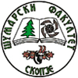

- Wageningen University, The Netherlands



Financed by:


The World Bank /PROFOR

Project approach

The two case studies for Sustainable Forest Management (SFM) in Albania on watershed management and Kosovo on wood biomass are connected in their effort to indicate the role and impact of SFM in providing environmental services and the options to finance such SFM.

This research project touches on complex issues of validating Sustainable Forests Management for Payment of Environmental Services.

The project needs to assure the following outcomes and impacts:

Scientific sound research will validate practices and stakeholder priorities in the field. The proposed research will therefore be practice based and oriented and provide solutions for bringing payments for environmental services in practices.

Scientific research & analysis
Practices & validation
Stakeholder involvement
Sound PES solutions
for
Sustainable Forest Management

Payment for Environmental Services approach
Payments for Environmental Services (PES) are first and foremost an incentive-based environmental management tool to protect and enhance the provision of environmental services.
In Albania the communal forest management concept has proven its value and is fully incorporated in the forestry sector. This gives a good base for included PES for SFM.
In Kosovo firewood is the most important wood product, while use of firewood is contributing to almost 10% of Kosovo’s energy consumption. The importance of firewood provides good opportunities to capture wood biomass and SFM with PES.
The process of designing a system of payments for environmental services can be broken into several steps:
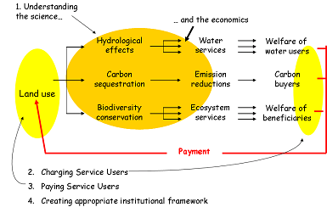

Multi Stakeholder and Participatory Process
The complex nature of SFM in relation to environmental services and the many actors involved a wide stakeholder involvement. The research is using inputs, information and opinions from all stakeholders to be able to make the needed analysis and development of methodology. The need to change attitude, willingness for PES needs an inclusive approach.

During the whole project a multi-stakeholder and participatory Process will be applied.

Surveys, group discussions, key person interviews, workshops, field visit are used for the data collection process and checking existing data gaining increased reliability of data. Validation of data with the key stakeholders and specific target groups is providing an increased base to be able to the analysis.

Review of land use, people and land use systems
The actual and potential land use, its users and managers and systems applied are important to be able to assess the proper PES. Land use and systems are identified and described and who is using, managing under which systems.

The Albania case specific topography maps of the Ulza watershed made describing the watershed and the land use within.

Erosion measurement in Ulza Watershed
The erosion sampling methodology is crucial to be able to validate the effect of different land use types and land management.

A net of 48-51 points are established on for erosion measurement in three locations with 15 regular points each and few additional irregular points for gully erosion measurements. The location is based on complete defined watershed, soil and land use types.

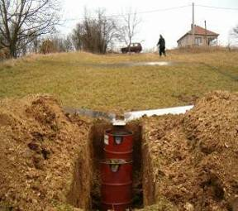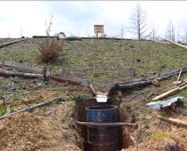
Example of measuring plots

Erosion measurement is made for one year with measurements after each every rainfall by local trained staff, measuring quantity of water and sediments and preserving a small sample. This measuring is done with people directly living at the sites and in cooperation with the Communal Forest Users Associations.

Value chain approach for wood biomass
In the Kosovo case on wood biomass a value chain approach is followed to analyse the situation. The value chain approach gives a good opportunity to view the production of wood biomass, processing and consumption at all its levels.
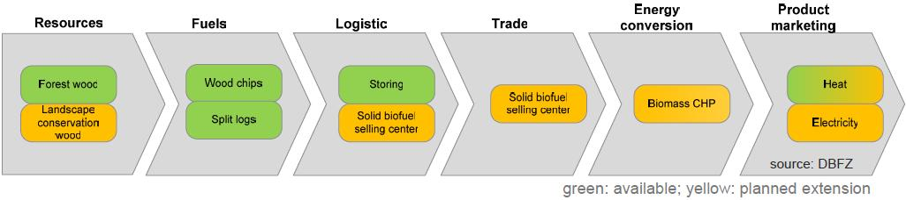
Example wood biomass value chain

Wood biomass is assessed for all sources of forest biomass as forest residues after harvesting, and potential of biomass production through pre commercial thinning for improving the forest health and use of agroforestry.

The use of biomass in its traditional form of firewood as well on innovative biomass for pellets, briquettes and wood chips are reviewed, including transportation and energy efficiency.

Feasibility of energy systems
Specific feasibility for three situations (large public building, rural public building and rural residential building) is made for the best wood burning system. The situation of the energy needs for the selected buildings, the availability of wood fuels, and the current situation concerning the technology are reviewed.

Different wood burning systems are assessed for each study. The economic potential of the selected biomass boiler with heat accumulator and radiator system is then assessed using a standardised set of calculations to generate Internal Rates of Return (IRR) values and Simple Payback Periods. The building energy saving measures will be included in the analysis to obtain an optimal efficiency.

Forest management practices
In both cases the different forest land use types are described including the management practices.

In Kosovo, for example specific attention is given to the actual system of forest management and relations of increment rate with the age in oak coppice forest, to propose the optimum rotation on fuel wood production.
The research on erosion run off, the forest management plans and the surveys provide input on the potential for erosion control. This will be further assessed towards optimal Sustainable Forest Management practices and systems. Since many forests are based on small scale forest holders and need to provide multiple objectives for both production and services multi function forest management systems will provide one of the specific practices. Farmer forest is one of the examples that are used.

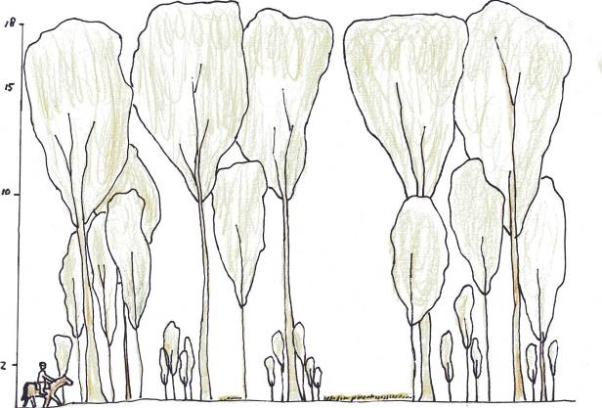Small scale forestry; farmer forests practice

Explore economics; construct service models and opportunity costs
Effective payments for environmental services schemes require secure sources of financing. In order to gain the understanding and willingness of beneficiaries of payments for environmental services, realistic economic models need to be prepared and agreement gained. Based on the quantitative and qualitative data and information collected, various models will be constructed of the various environmental services identified and generated by different kinds of country and site specific land uses and wood utilisation systems.

Information generated from the analysis of services produced from different land uses and land management systems will be used to make recommendations as to targeting specific systems and areas for targeted payments.

http://web.worldbank.org/WBSITE/EXTERNAL/TOPICS/ENVIRONMENT/EXTEEI/0,,contentMDK:20487921~menuPK:1187844~pagePK:210058~piPK:210062~theSitePK:408050~isCURL:Y,00.html

